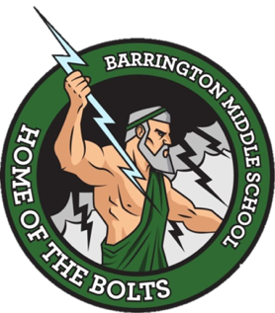

Barrington Middle School
SAC Agenda
February 22, 2023
Room 365

- Attendance

- Call to Order

- Approval or Correction of Minutes from November 16, 2022

- New Business
- Update on Barrington data (Ms. Cummings)
- Upcoming assessments

- Announcements (for the good of the group)
  - Next Meeting March 22, 2023 at 8:40 AM

- Adjournment

